AIM 6. Homework Name:___________________________

Find the domain and range for the following graphs.
Hints: A line is composed of multiple points. You may write your answers as a sentence instead of in the brackets.
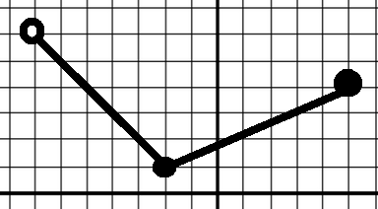
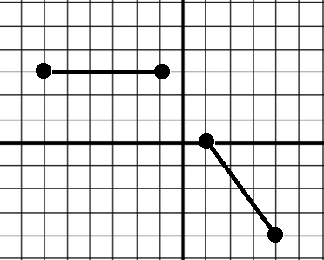
1. 2.

Domain: Domain:

Range: Range:

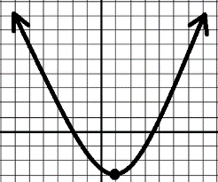
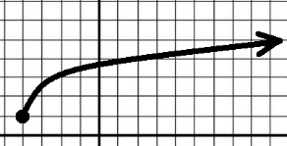
3. 4.

Domain: Domain:

Range: Range:

